EXPERIMENT – 9
Comparison of Linear and Polynomial Regression using Python
AIM
To implement and compare Linear Regression and Polynomial Regression algorithms using Python.
APPARATUS REQUIRED
- Google Colab
- Python 3.x
ALGORITHM
- Start the program.
- Import the required Python libraries.
- Create or load the dataset.
- Separate the input and output variables.
- Split the dataset into training and testing data.
- Create a Linear Regression model.
- Train the Linear Regression model.
- Create Polynomial Features from the input data.
- Train the Polynomial Regression model.
- Predict the output using both models.
- Calculate and compare the performance of both models.
- Plot the regression results.
- Stop the program.
PROGRAM
# Experiment 9: Comparison of Linear and Polynomial Regression
import numpy as np
import matplotlib.pyplot as plt
from sklearn.linear_model import LinearRegression
from sklearn.preprocessing import PolynomialFeatures
from sklearn.metrics import mean_squared_error, r2_score
# Dataset
X = np.array([1, 2, 3, 4, 5, 6, 7, 8, 9, 10]).reshape(-1, 1)
y = np.array([2, 4, 7, 10, 15, 20, 27, 34, 43, 52])
# Linear Regression
linear_model = LinearRegression()
linear_model.fit(X, y)
y_linear = linear_model.predict(X)
# Polynomial Regression
poly = PolynomialFeatures(degree=2)
X_poly = poly.fit_transform(X)
poly_model = LinearRegression()
poly_model.fit(X_poly, y)
y_poly = poly_model.predict(X_poly)
# Performance evaluation
linear_mse = mean_squared_error(y, y_linear)
linear_r2 = r2_score(y, y_linear)
poly_mse = mean_squared_error(y, y_poly)
poly_r2 = r2_score(y, y_poly)
print("Linear Regression")
print("Mean Squared Error:", linear_mse)
print("R2 Score:", linear_r2)
print("\nPolynomial Regression")
print("Mean Squared Error:", poly_mse)
print("R2 Score:", poly_r2)
# Plot results
plt.scatter(X, y, label="Actual Data")
plt.plot(X, y_linear, label="Linear Regression")
plt.plot(X, y_poly, label="Polynomial Regression")
plt.xlabel("X")
plt.ylabel("Y")
plt.title("Linear vs Polynomial Regression")
plt.legend()
plt.show()
OUTPUT
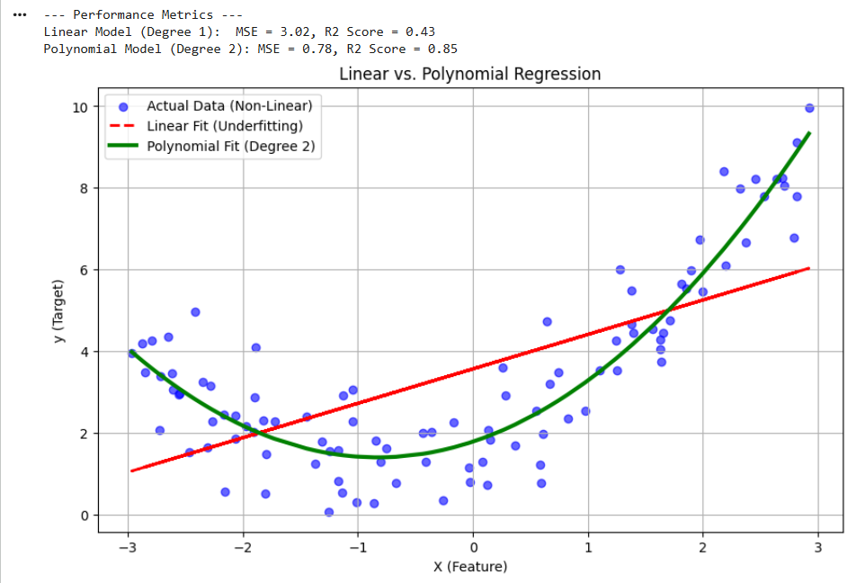
RESULT
Thus, Linear Regression and Polynomial Regression were successfully implemented using Python in Google Colab, and their performances were compared using appropriate evaluation metrics.

